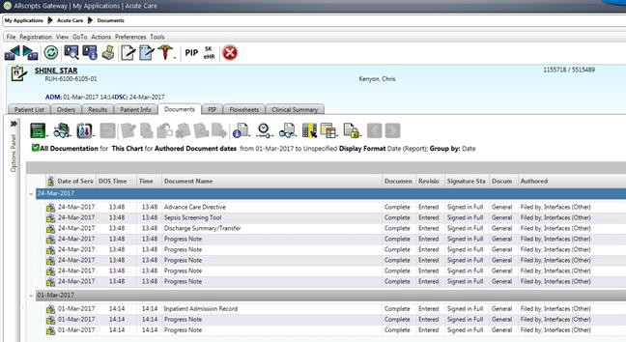
Viewing Scanned Documents via Sunrise Clinical Manager (SCM)
Scanned documents appear in SCM with a Media Viewer icon.

Double click the icon to launch the document – a new Internet Explorer tab will open and user will be auto- logged into the viewer application and on the document/patient in context.

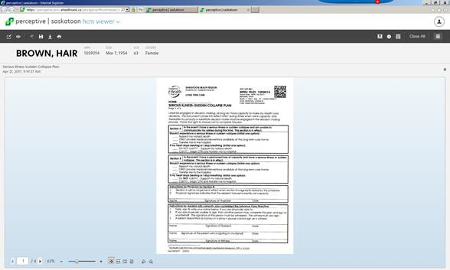

PLEASE NOTE: If the user tries to open the document in SCM by double-clicking the line item rather than the Media Viewer icon the following message will appear. Close the window and double-click the Media Viewer icon.

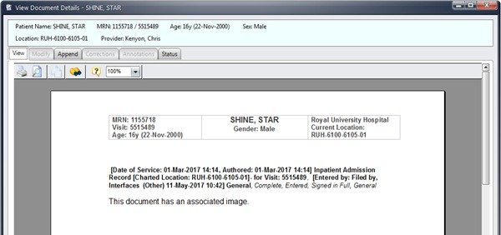

Viewing Documents

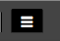
After viewing the scanned document, the user can browse through all of the patient’s scanned documents in the viewer application by clicking the menu icon.

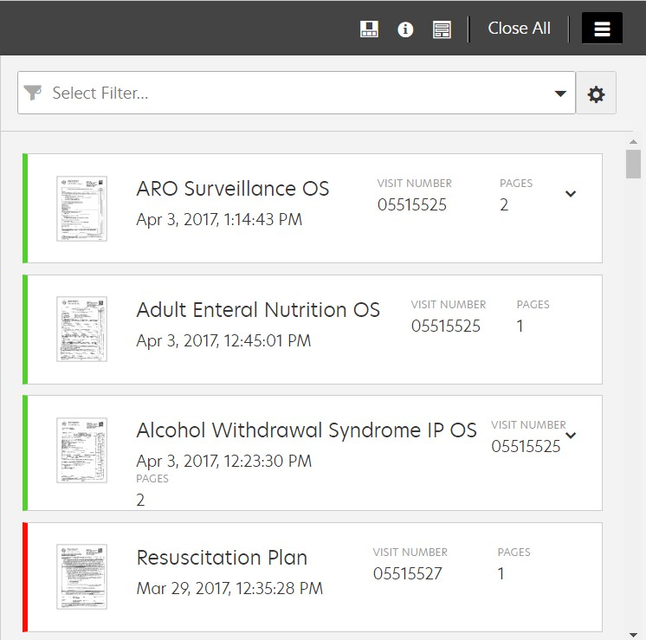
After clicking the menu icon, all scanned documents for all visits for that patient will display.

Users can click a scanned document thumbnail to open it. Close the menu icon by clicking on the menu again so the document can be viewed. When finished viewing the document click the ‘x’ in the upper right corner of the document to close it. Do not close the window.

Filtering

In the Scanning application viewer, users have the ability to create and save their own filters to display only the scanned documents you would like to view. Click the gear icon to create a filter, enter all the filter information, then save the filter.

- In the filter window, click the gear icon.
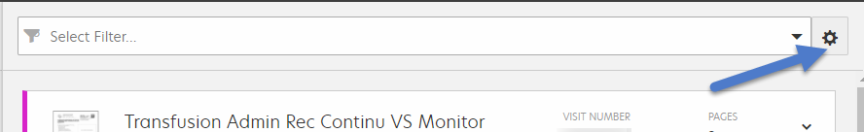

- This will bring up the filter menu selection where you can create a custom filter.

- The simplest filter to create is a categories filter which groups the scanned documents into broad groupings of similar documents.
  - Name the filter under filter name
  - Select the ‘Show Categories’ box

  - Select the ‘Set as Default’ box if you want this to be your default filter
  - Click Save
  - Click Apply
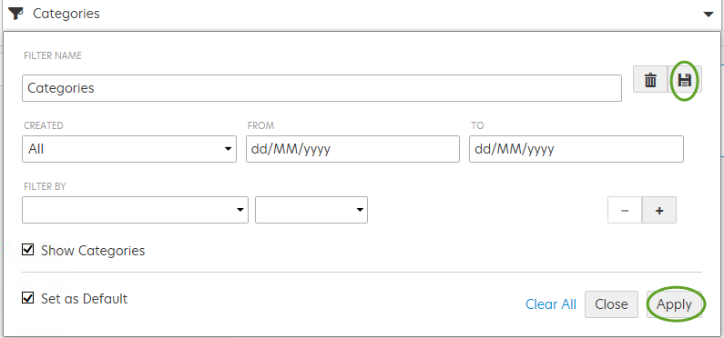

Note: Only the categories that have documents associated with them will be displayed. There are 55 categories that the documents could group under (not all are pictured here).

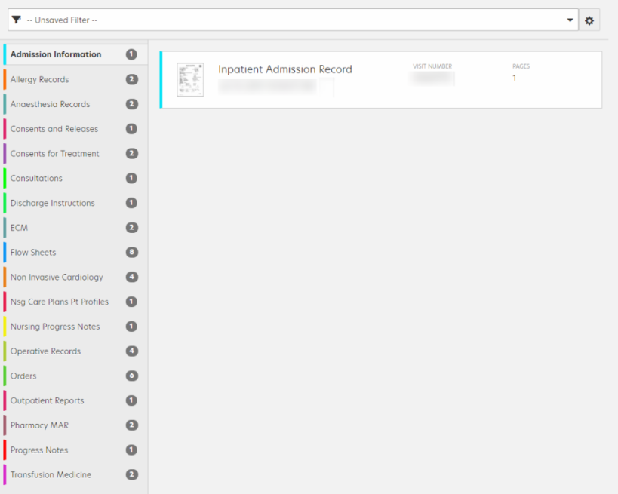
**It is a good practice and recommended to always look in the ECM Category (if it is displayed) and if you can’t find the document you are looking for under the correct category. This category contains documents that have not been built in the system yet.

- To create a filter for specific scanned documents:
  - Name the filter (e.g. Practitioners Orders) and then select the parameters you want

  - Add dates if required (Note: the dates of the documents viewed in this application are the date the document was scanned so you may need to extend your date range to allow for turnaround time from date of discharge to date of scanning). If date ranges are not required, leave the ‘Created’ field set to ‘All’.
  - If dates are required, select them from the calendar in the ‘From’ and ‘To’ fields or select from the ‘Created’ drop down menu as shown.

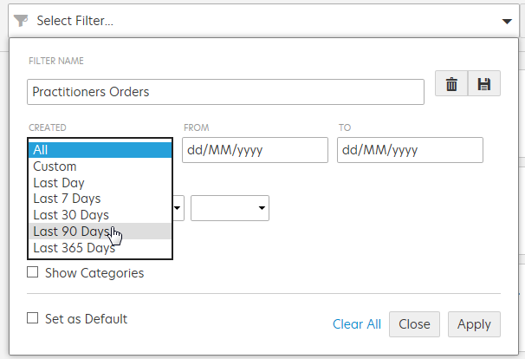

- The ‘Filter By’ section is very powerful and will provide you with many options. The most common ‘Filter By’ option will be the ‘Type’ selection which is a filter on document name.

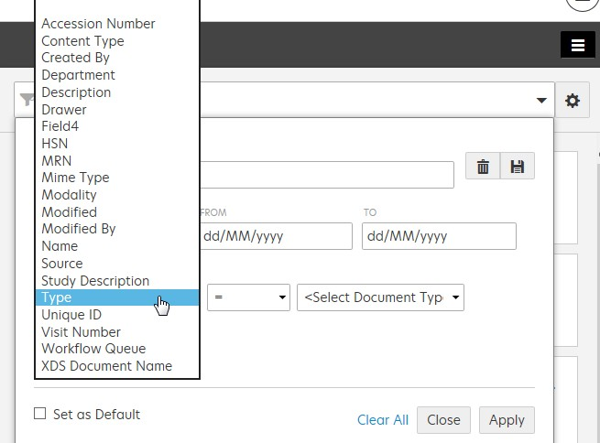

- Select :
= - equal to a specific type of document
Is one of - select multiple types of documents
!= - not equal to a specific document

Is none of – excludes multiple types of documents

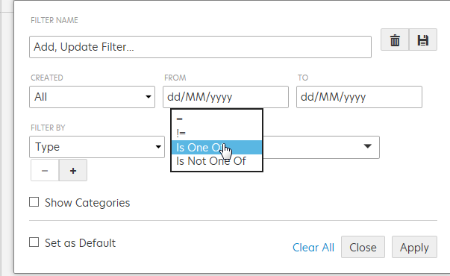

- Select your document type by typing in the document name (e.g. Practitioners Orders)

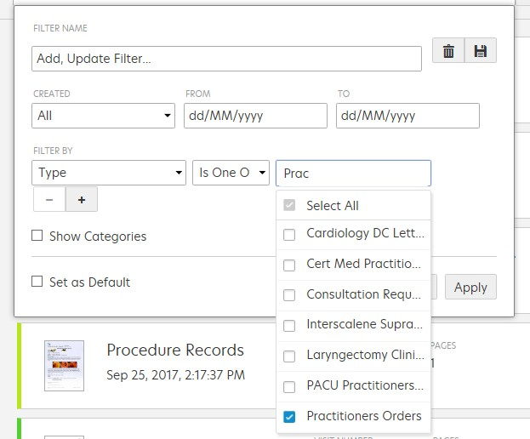

- When complete, save your filter by using the save button 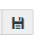and then click Apply

- You can now select your filter from the dropdown menu or clear your current filter

After selecting your filter from the dropdown, your selected scanned documents will display or not display based on your selection criteria.

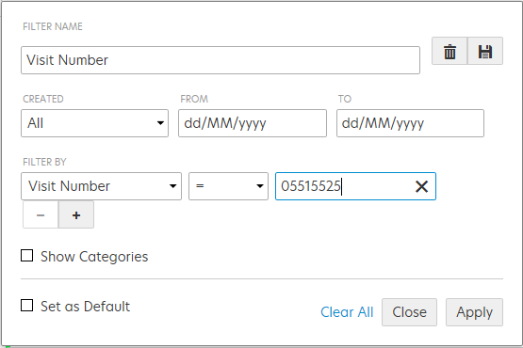
Below is a sample of a filter where documents from only 1 visit will be displayed. This may be helpful when wanting to view documents from 1 admission only.

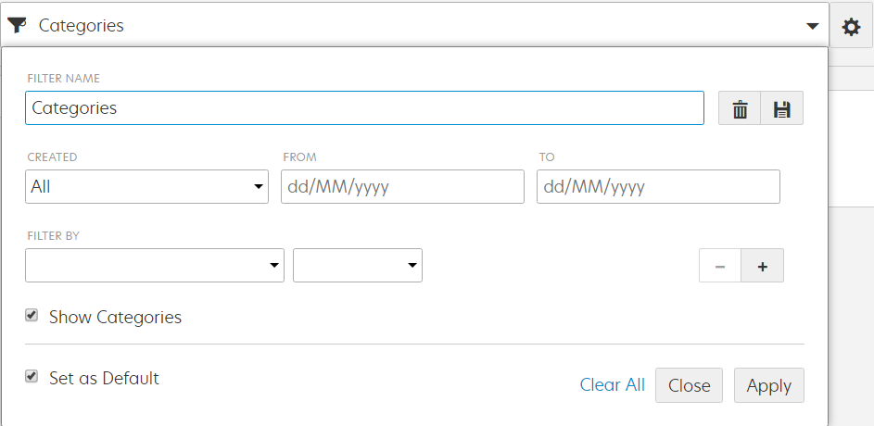
Users can display document categories – broad groupings of similar documents, in order to assist with searching and finding a document more quickly. Click on the “Show Categories” button. Click Apply.

The document categories appear as seen in the sample below.

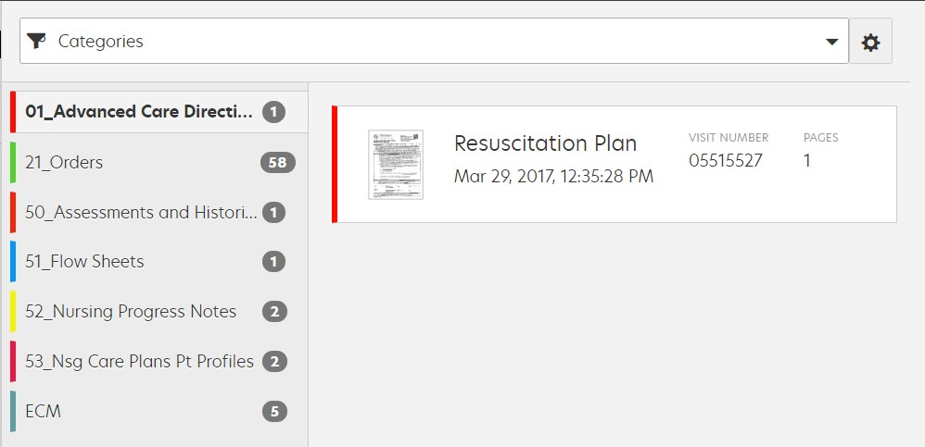

Viewing Multiple Documents

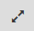
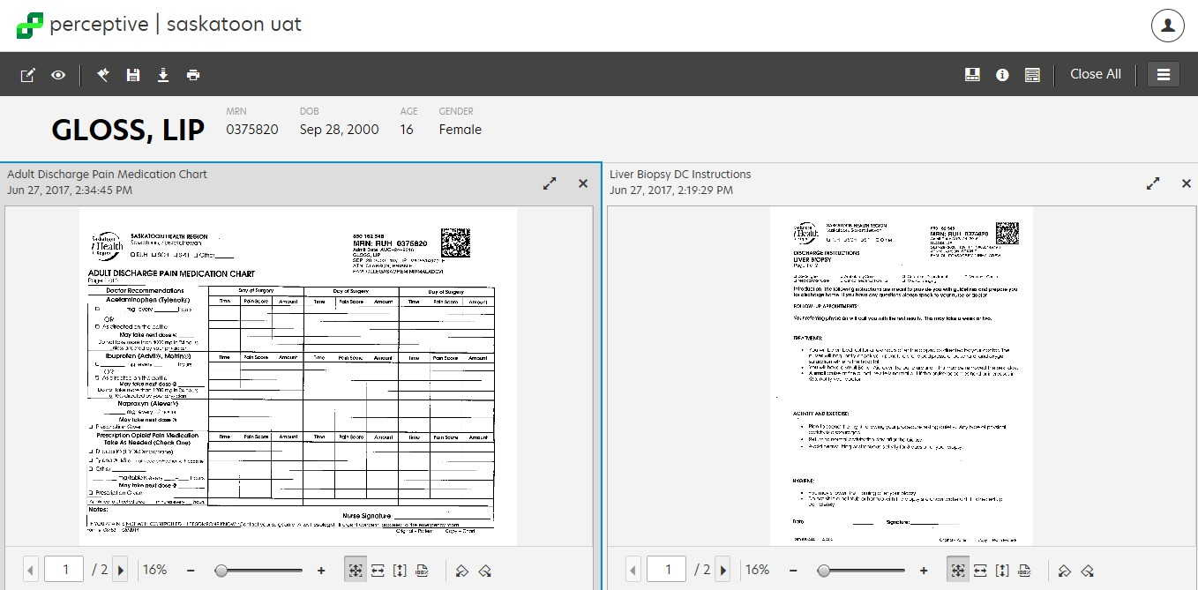
If it is helpful to review multiple scanned documents at one time, users can click the documents to view and the documents will open side-by-side. Double clicking the top bar of an outlined document will make it the primary document and provide a zoom-like function to make the document larger. Clicking on the double arrow icon will get the same result.

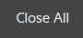
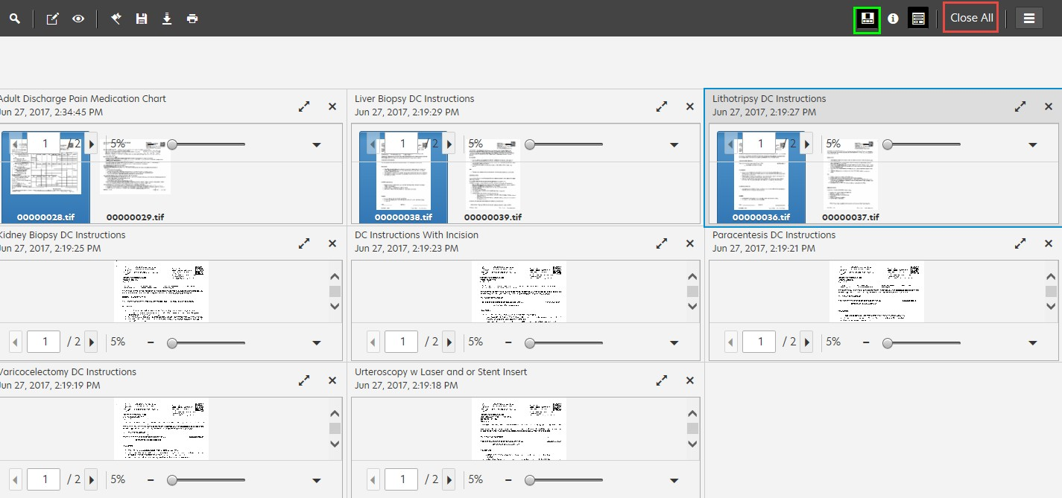
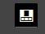
Users can close all scanned documents by clicking on the “Close All” button.
Users can open up the multiple pages of the document by clicking on the
“Show or Hide Thumbnails” button

Once finished viewing scanned documents in the viewer, close the Internet Explorer window by clicking on the ‘x’ on the tab.

If you would like to go back to SCM click the green globe at the bottom the screen
Note: If you go back into SCM and click on another scanned document without closing the previous Perceptive tab you will end up with multiple Perceptive windows open.

